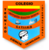 **INSTITUTO TÉCNICO INTERNACIONAL I.E.D JORNADA TARDE**

**GUÍA DE TRABAJO: INGLÉS GRADO: SEGUNDO DOCENTE: MARA VENEGAS**

**NOMBRE:___________________________________________CURSO:________________**

**Objetivo: Identificar el vocabulario de las prendas de vestir, las partes del cuerpo y el verbo to have para mejorar la pronunciación en inglés y utilizarlo en frases.**

**Dear students the following workshop is designed to learn and review some clothes, the parts of the body and the verb to have.**

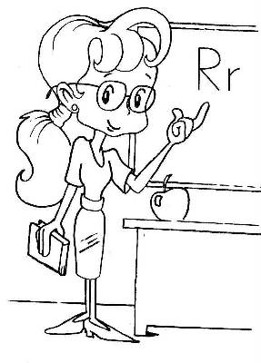

**Task description**

1. **Look the following video about clothes**

[**https://www.youtube.com/watch?v=5iT7Uv8JoAI**](https://www.youtube.com/watch?v=5iT7Uv8JoAI) **and practice the pronunciation.**

1. **Look the following video about the parts of the body**

[**https://www.youtube.com/watch?v=AsM1cgsip-o&list=RDAsM1cgsip-o&start_radio=1**](https://www.youtube.com/watch?v=AsM1cgsip-o&list=RDAsM1cgsip-o&start_radio=1)

**and practice the song.**

**Draw the human body and write the parts in English in your notebook.**

1. **Go to this link** [**https://www.youtube.com/watch?v=sElRX5Uxu00**](https://www.youtube.com/watch?v=sElRX5Uxu00) **and write 5 sentences using the verb have with the parts of the body in your notebook.**

**Example: I have two hands**

**Yo tengo dos manos**