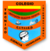 **INSTITUTO TÉCNICO INTERNACIONAL I.E.D JORNADA TARDE**

**GUÍA DE TRABAJO: INGLÉS GRADO: QUINTO DOCENTE: MARA VENEGAS**

**NOMBRE:___________________________________________CURSO:________________**

**Objetivo: Identificar los tiempos presente simple y presente continuo.**

**Dear students the following workshop is designed to learn affirmative, negative and interrogative sentences in simple present tense and present continuous tense.**

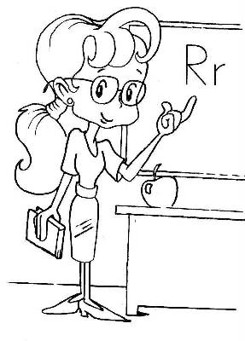

**Task description**

1. **Look the following video about simple present and practice.**

[**https://www.youtube.com/watch?v=sfjUz-Oyq5E**](https://www.youtube.com/watch?v=sfjUz-Oyq5E)

1. **Look the following video about the auxiliaries DO AND DOES** [**https://www.youtube.com/watch?v=1bSsLLILAmY&list=RDCMUC0lQjhGes9MXEzeIp54RLGA&index=2**](https://www.youtube.com/watch?v=1bSsLLILAmY&list=RDCMUC0lQjhGes9MXEzeIp54RLGA&index=2) **and write in your notebook affirmative, negative and interrogative sentences.**

1. **Go to this link and learn to use the present continuous tense.**

[**https://www.youtube.com/watch?v=CkWCzB8dk2U&list=RDCMUC0lQjhGes9MXEzeIp54RLGA&index=3**](https://www.youtube.com/watch?v=CkWCzB8dk2U&list=RDCMUC0lQjhGes9MXEzeIp54RLGA&index=3)