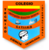 **INSTITUTO TÉCNICO INTERNACIONAL I.E.D JORNADA TARDE**

**GUÍA DE TRABAJO: INGLÉS GRADO: TERCERO DOCENTE: MARA VENEGAS**

**NOMBRE:___________________________________________CURSO:________________**

**Objetivo: Aprender e identificar algunos temas como: asignaturas, días de la semana y preposiciones de lugar en inglés para ampliar el vocabulario en la asignatura.**

**Dear students the following workshop is designed to learn and review some school subjects and days of the week. You will understand the use of prepositions.**

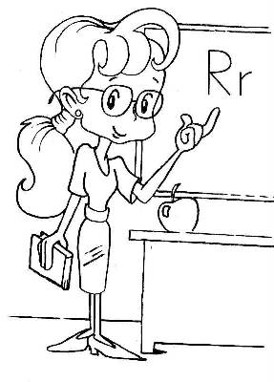

**Task description**

1. **Look the following video about school subjects** [**https://www.youtube.com/watch?v=AnZxeX_8mVk&t=8s**](https://www.youtube.com/watch?v=AnZxeX_8mVk&t=8s)

**and practice the pronunciation.**

1. **Look the following video about the days of the week** [**https://www.youtube.com/watch?v=5cYMu3RTMJU**](https://www.youtube.com/watch?v=5cYMu3RTMJU)**and practice the song.**

**Answer the question: What day is today? _______________________**

1. **Go to this link** [**https://www.youtube.com/watch?v=8F0NYBBKczM**](https://www.youtube.com/watch?v=8F0NYBBKczM) **and identify the prepositions of place, answer the following questions.**
2. **Where is the monkey?**
3. **Where is the bird?**
4. **Where is the snake?**
5. **Where is the apple?**
6. **Where is the pumpkin?**